

**US Army Corps of Engineers**

**Afghanistan Engineer District**

AED Design Requirements:

Grease Trap Design

Various Locations, Afghanistan

September 2009

**TABLE OF CONTENTS**

AED DESIGN REQUIREMENTS FOR

GREASE TRAP DESIGN VARIOUS LOCATIONS, AFGHANISTAN

Section Page

**1. General 1**

**2. Grease Traps 1**

**3. Configuration 1**

**4. Discharge to Grease Traps 1**

**5. Design Factors 1**

**6. Grease Trap Design 2**

**7. As-Builts 2**

**8. Reference 2**

**Appendix A Grease Trap / Grease Interceptor Design Layout 3**

**1. General**

The purpose of this document is to provide requirements to Contractors for any project requiring grease trap design and construction.

**2. Grease Traps**

Food-service operations typically use grease traps to trap fats, oils and grease (FOG) and to prevent excessive discharge of FOG into the wastewater collection and treatment system. If grease traps are not properly designed and maintained, slug loads of grease will interfere with the performance of both the collection and treatment system. Grease traps are generally located outside the food-service establishment in an underground tank with ground-level access. The traps use the physical principal that fats, oils and grease are lighter than water and will rise to the top of a water surface when the mixture is allowed to stand for a period of time in quiet conditions. A submerged pipe at the outlet of the tank allows water to exit the tank while retaining the FOG materials. .

**3. Configuration**

Grease traps usually consist of an underground, watertight, concrete tank with baffled inlet and outlet piping. The outlet pipe has a tee that allows the internal discharge to be located within 0.3 m of the tank bottom. The size of the grease trap depends on the anticipated flow rate, water temperature,

and grease concentration. In general, grease traps range from a minimum capacity of 2.8 m3 to a maximum capacity of 4.7 m3. Where a capacity of more than 4.7 m3 is required, two or more grease

traps may be placed in a series. Access to the tank is typically through one or two manhole rings and covers. Grease traps should be located outside food-service buildings in an accessible location for inspection and maintenance. The traps are installed in the waste line between the sink drains, floor

drains and kitchen fixtures and the wastewater collection system.

**4. Discharge to Grease Traps**

Grease traps do not perform effectively if they receive discharges with elevated temperatures or high solids concentrations. Grease traps should not receive discharges from garbage grinders or produce- preparation sinks. Discharges from mechanical dishwashers are also not recommended. However, the pre-flush / pre-scraping sinks that serve mechanical dishwashers may be connected to the grease trap, provided no garbage grinders are used at these sinks. Kitchen food wastes and kitchen cleaning wastes are discharged from the building in a separate line which flows to the grease trap.

Grease traps do not receive sanitary waste from the facility. Sanitary wastes flow directly to the wastewater collection system through separate piping.

**5. Design Factors**

The design factors to consider when sizing a grease trap are as follows: Flow rate of discharge to grease trap.

Retention time in the grease trap.

FOG concentration of the influent waste. Emptying frequency.

**6. Grease Trap Design**

There are several methods of determining the size of a grease trap. The most common method is provided by the U.S. Environmental Protection Agency (EPA) and is as follows:

Trap size = (# seats)*(flow/meal)*(storage factor)*(hours open/2)

Where:

# Seats = number of available seats in dining facility (not number of meals served) Flow/meal = 0.02 m3

Storage Factor = 1.7

Hours open = Preparation time +serving time cleaning time for EACH meal. For example, if a facility serves 3 meals per day and each meal requires 1 hour to prepare a meal, 1.5 hour to serve each meal, and 1 hour to clean the

facility, then the total hours open would be 3 x (1.5 hour serving) = 4.5 hours.

A grease sized for a dining facility with 50 seats with the serving times listed above would be:

50 x 0.02 x 1.7 x (4.5 / 2) = 4.8 cubic meters

The liquid depth in the trap should be between 0.76 m and 1.82 meters and the length to width ratio should be a minimum of 3 to 1.

**7. As-Builts**

Upon completion of the installation, the Contractor shall submit editable CAD format As-Built drawings. The drawing shall show the final product as it was installed in the field, with the exact dimensions, locations, materials used and any other changes made to the original drawings. Refer to Contract Sections 01335 and 01780A of the specific project for additional details.

**8. Reference**

EPA, 625/1-80-012 (Design Manual: Onsite Wastewater Treatment and Disposal Systems)

**Grease Trap / Grease Interceptor Design Layout**

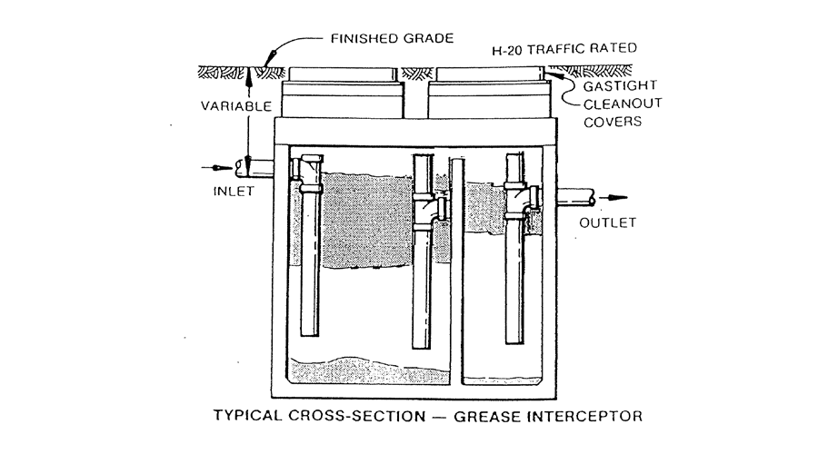

FOG

Sludge

Notes:

1. Piping inside grease trap shall be 100mm diameter, PVC with solvent welded joints

2. Bottom of inlet and outlet piping shall be 300mm above floor of tank.

3. bottom of interior baffle / connection piping shall be 500mm above floor of tank.

4. Grease trap shall be pumped out regularly to prevent solids buildup and clogging.

5. Volume of inlet chamber shall be 3 times volume of outlet chamber.

6. Length-to-width ratio of tank configuration shall be 3:1.

7. Tank depth shall be between 0.76 – 1.82 m.

8. Minimum volume = 2.8 m3

9. Maximum volume for a single grease trap = 4.7 m3.